Practical No:04
Write the concept of Looping in python & Write a python program for printing heart shape
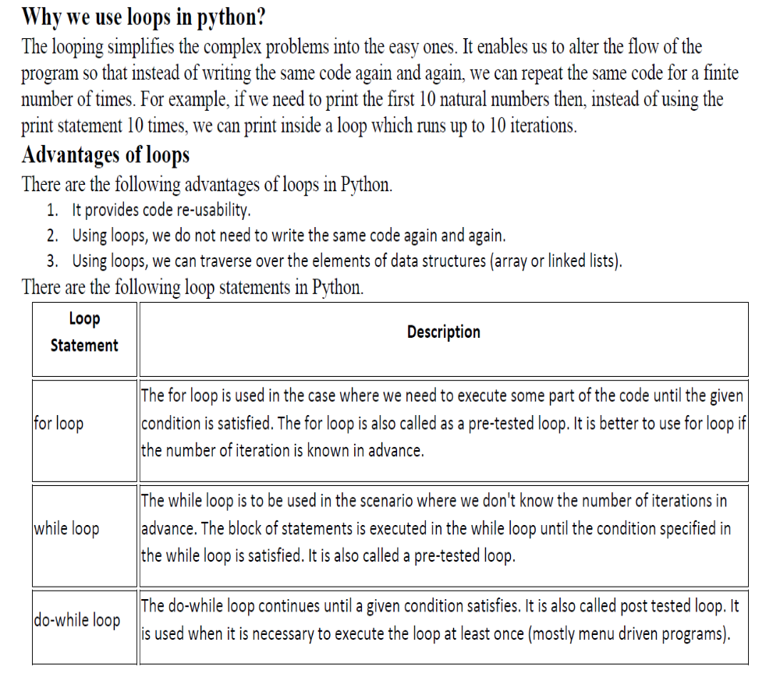
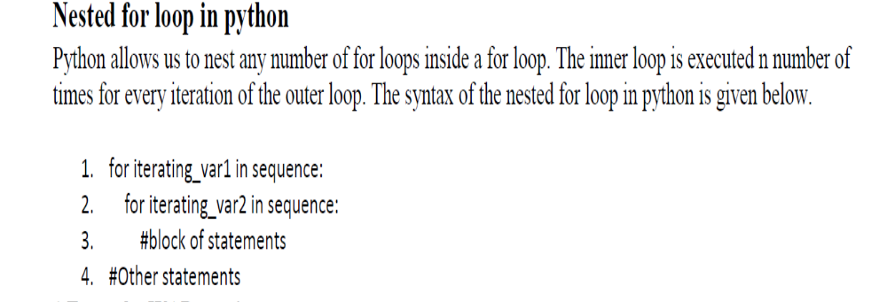

Program:
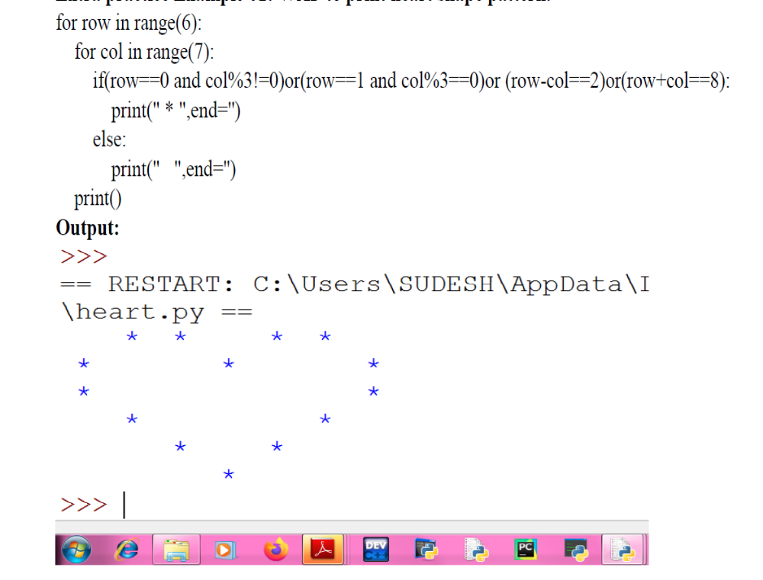
Result: We have successfully studied use of nested looping by different patterns.

